National College of Computer Studies
Paknajol, Kathmandu



Project on
“Nutriplus Store”
as required for the partial fulfillment of the
B.Sc. CSIT 6th Semester
affiliated to Tribhuvan University.

Submitted by: Submitted to:
Abinash Shrestha Pratiksha Poudel
Basanta Pakhrin
Suraj Timsina

Supervisor’s Recommendation

I hereby recommend that this project prepared under my supervision by ABINASH SHRESTHA, BASANTA PAKHRIN and SURAJ TIMSINA entitled “NUTRIPLUS STORE” in partial fulfillment of the requirements for the degree of B.Sc. in Computer Science and Information Technology be processed for the evaluation.

…………………………………………
Pratiksha Poudel

Student’s Declaration

We hereby declare that the project work entitled “NUTRIPLUS STORE” submitted to Institute of Science and Technology, Tribhuvan University, Kathmandu, National College of Computer Studies, Kathmandu, is for the degree is submitted in partial fulfillment of requirements for the degree of Bachelor of Science in Computer Science and Information Technology (BSc.CSIT). This report contains all the original research and analysis with some information taken from other resources which are properly cited.

…………………………………………
Abinash Shrestha
Basanta Pakhrin
Suraj Timsina

LETTER OF APPROVAL

This is to certify that this project prepared ABINASH SHRESTHA, BASANTA PAKHRIN and SURAJ TIMSINA entitled “NUTRIPLUS STORE” in partial fulfillment of the requirements for the degree of B.Sc. in Computer Science and Information Technology has been well studied. In our opinion it is satisfactory in terms of scope and quality as a project for the required degree.

………………………………
Pratiksha Poudel
Supervisor

ACKNOWLEDGEMENT
We would like to express our sincere gratitude to Pratiksha Poudel, for her valuable guidance, continuous support, and encouragement throughout the completion of this project. Her insights and suggestions were instrumental in shaping our work.

We are also thankful to National College of Computer Studies for providing the necessary resources and facilities, which greatly assisted us in carrying out this project successfully.

Our special thanks go to all individuals who shared their knowledge and experiences related to e-commerce systems, online business operations, and digital platforms, which significantly enriched our understanding and strengthened the overall quality of the project.

Finally, we extend our appreciation to each member of our group for their teamwork, dedication, and cooperation, which made this project possible.

Sincere Gratitude
Abinash Shrestha
Basanta Pakhrin
Suraj Timsina

ABSTRACT
This project is a full-stack web application developed using the MERN stack (MongoDB, Express.js, React.js, and Node.js) along with HTML, CSS, JavaScript, and Bootstrap to provide a responsive, scalable, and user-friendly system. The application is designed to offer an interactive interface and efficient data management for modern web-based operations.

The frontend of the system is built using React.js, enhanced with HTML, CSS, JavaScript, and Bootstrap, ensuring a dynamic user experience, responsive design, and cross-browser compatibility. The backend is developed using Node.js and Express.js, which handle server-side logic, API management, and communication between the client and the database. MongoDB is used as the database to store and manage application data efficiently due to its flexibility and scalability.

The system supports essential functionalities such as user interaction, secure data handling, and real-time updates through RESTful APIs. The modular architecture of the MERN stack allows easy maintenance, future enhancements, and high performance. Overall, this project demonstrates the effective use of modern web technologies to build a robust, efficient, and scalable web application suitable for real-world applications.
Table of Contents
Supervisor’s Recommendation ii
Student’s Declaration iii
LETTER OF APPROVAL iv
ACKNOWLEDGEMENT v
ABSTRACT vi
Chapter 1: INTRODUCTION 1
1.1 INTRODUCTION 1
1.2 PROBLEM STATEMENT 1
1.3 OBJECTIVE 2
1.4 SCOPE 2
1.5 REPORT ORGANIZATION 2
1.5.1 Introduction 2
1.5.2 Background Study 2
1.5.3 System Analysis and Design 2
1.5.4 Implementation and Testing 3
1.5.5 Conclusion and Further Recommendations 3
Chapter 2: BACKGROUND STUDY 4
2.1 BACKGROUND STUDY 4
2.1.1. Study of Existing System 4
2.1.2. Literature Review 5
Chapter 3: SYSTEM ANAYSIS AND DESIGN 7
3.1. SYSTEM ANALYSIS 7
3.1.1. Requirement Analysis 7
3.1.2. Feasibility Study 7
3.1.3. Data Modelling 8
3.1.4. Process Modelling 11
3.2. SYSTEM DESIGN 15
3.2.1. Architectural Design 15
3.2.2. Database Schema Design 16
Chapter 4: IMPLEMENTATION AND TESTING 18
4.1. IMPLEMENTATION 18
4.1.1. Tools Used 18
4.1.2. Implementation Detail of Module 18
4.2. TESTING 19
Chapter 5: CONCLUSION AND FUTURE RECOMMENDATION 20
5.1. LESSON LEARNT 20
5.2. CONCLUSION 20
5.3. FUTURE RECOMMENDATION 21
References 22
Appendices 23

List of Figures
Figure 1: DFD Level 0 9
Figure 2: ER Diagram 10
Figure 3: Use Case Diagram 11
Figure 4: Activity Diagram of Admin 12
Figure 5: Activity Diagram of User 13
Figure 6: Sequence Diagram 14
Figure 7:User Schema 16
Figure 8: Product Schema 16
Figure 9: Order Schema 17
Figure 10: Homepage Wireframe 23
Figure 11:User profile page wireframe 24
Figure 12: Admin Homepage wireframe 25
Figure 13: Product Dashboard wireframe 26
Figure 14: User Dashboard wireframe 26
Figure 15: Sign in Page of Nutriplus store 27
Figure 16: Home Page of Nutriplus store 27
Figure 17: Cart of Nutriplus store 28
Figure 18: Order Confirmation Page 28
Figure 19: Payment of Nutriplus Store 29
Figure 20:Order Summary Page 29
Figure 21: Admin User Dashboard 30
Figure 22: Admin Product Dashboard 30
Figure 23: Admin Order Dashboard 31

INTRODUCTION

INTRODUCTION
The Nutriplus Store is a comprehensive web-based application developed using the MERN (MongoDB, Express.js, React.js, Node.js) stack to support the online sale of nutritional and fitness supplements. With the rapid growth of health awareness and fitness culture, the demand for supplements such as protein powders, vitamins, minerals, and health boosters has increased significantly. This project aims to provide a digital platform where customers can easily explore, compare, and purchase supplement products without visiting a physical store.

The system offers an interactive and responsive user interface that enables customers to browse products by category, view detailed descriptions, prices, and benefits, and manage their shopping cart efficiently. The backend of the application handles user authentication, product management, order processing, and secure data storage. By integrating modern web technologies, the Nutriplus Store ensures better performance, scalability, and maintainability.

Overall, this project focuses on simplifying the buying process for customers while providing store administrators with effective tools to manage inventory, orders, and users. The application serves as a practical implementation of full-stack web development concepts using the MERN stack.

PROBLEM STATEMENT
n many traditional supplement stores, business operations are still handled manually or with limited digital support. Customers must physically visit the store to check product availability, compare prices, or obtain product details. This leads to inconvenience, especially for customers with limited time or those living far from the store. Additionally, physical stores operate within fixed business hours, restricting customer access.
From the business perspective, maintaining manual records for inventory, sales, and customer information is inefficient and prone to errors. Tracking stock levels, managing orders, and generating sales reports becomes difficult as the business grows. Lack of proper data management can result in overstocking, stock shortages, and poor customer service.
Therefore, there is a strong need for an online supplement store that automates sales and inventory management, provides accurate product information, supports online ordering, and enhances overall customer experience through a reliable digital platform.

Key Problems Identified:
- Customers must visit the store physically to check product availability and prices.
- Limited business hours restrict customer access to products and services.
- Manual record-keeping leads to errors in inventory and sales data.
- Difficulty in tracking stock levels causes overstocking or stock shortages.
- Lack of centralized data makes reporting and decision-making inefficient.
- Poor customer experience due to slow service and limited information access.

OBJECTIVE
The primary objective of the Nutriplus Store is to design and develop a reliable and user-friendly online platform for selling nutritional and fitness supplements. The specific objectives of the project are as follows:
- To provide customers with easy access to a wide range of supplement products
- To display detailed product information including price, description, usage, and benefits
- To implement secure user registration and login functionality
- To allow users to add, update, and remove products from the shopping cart
- To enable smooth checkout and order placement processes
- To provide an admin panel for managing products, users, and orders
- To reduce manual work and improve operational efficiency of the store
- To enhance customer satisfaction through faster and more convenient services

SCOPE
The scope of the Nutriplus Store defines the boundaries and functionalities covered by the system. The project focuses on developing an online platform for a single supplement store with the following features:
- User registration, login, and authentication
- Browsing supplement products by category
- Searching and filtering products
- Viewing detailed product descriptions and prices
- Shopping cart management and checkout functionality
- Order placement and order history tracking
- Administrative control for managing products, categories, users, and orders

REPORT ORGANIZATION

Introduction
This section provides an overview of the project, including a brief introduction to the Nutriplus Store, the problem statement, objectives, and scope of the system. It explains the motivation behind developing the project and highlights the importance of an online supplement store in the modern digital era.

Background Study
The background study section discusses existing systems related to online shopping and supplement sales. It reviews traditional supplement store operations and existing e-commerce platforms, identifying their limitations. This section also introduces the MERN stack and explains why it was selected for developing the Nutriplus Store.

System Analysis and Design
This section focuses on the analysis and design of the system. It includes requirement analysis, identification of user roles, functional and non-functional requirements, and overall system architecture. Database design, data flow diagrams, and system models are explained to provide a clear understanding of how the system operates.

Implementation and Testing
The implementation and testing section describes the development process of the Nutriplus Store. It explains how frontend and backend components are implemented using the MERN stack. This section also discusses different testing techniques such as unit testing, integration testing, and system testing to ensure the reliability and correctness of the system.

Conclusion and Further Recommendations
This section summarizes the overall project, highlighting key achievements and outcomes of the Nutriplus Store. It evaluates how well the system meets the defined objectives and requirements. Additionally, it provides recommendations for future improvements such as mobile application support, advanced payment gateways, enhanced security features, and intelligent product recommendations.

BACKGROUND STUDY

BACKGROUND STUDY
The background study provides an understanding of the existing practices, technologies, and research related to online shopping systems, particularly in the domain of nutritional and fitness supplements. This chapter helps identify gaps in current systems and justifies the need for developing the Nutriplus Store using modern web technologies. It also provides insight into how similar systems operate and what improvements can be introduced.

Study of Existing System
HealthKart Online Supplement Store
- Features:
- Product Range: Offers a wide variety of health and fitness supplements such as protein powders, mass gainers, vitamins, minerals, pre-workouts, and wellness products.
- Brand Availability: Provides products from multiple national and international supplement brands.
- Shopping Experience: Includes a user-friendly interface with product filtering, reviews, and a secure shopping cart system.
- Mobile Responsiveness: The platform is optimized for mobile devices, ensuring smooth browsing and purchasing across different screen sizes. [1]

MuscleBlaze Official Store
- Features:
- Product Categories: Specializes in fitness supplements including whey protein, creatine, amino acids, and health foods.
- Product Information: Displays detailed nutritional information, usage instructions, and authenticity verification.
- User Engagement: Allows users to create accounts, track orders, and receive promotional offers.
- Mobile Compatibility: The website supports mobile and tablet devices for convenient access. [2]
General Nutrition Centers Online Store
- Features:
- Product Offerings: Provides supplements related to sports nutrition, weight management, vitamins, and herbal products.
- Security and Payments: Ensures secure payment gateways and data protection policies.
- Customer Support: Offers customer assistance, FAQs, and return policies to enhance trust.
- Cross-Platform Accessibility: The platform is accessible across desktop and mobile devices. [3]

Amazon – Health & Supplements Section
- Features:
- Product Variety: Hosts a wide range of supplement products from different sellers and brands.
- User Reviews: Allows customers to read ratings and reviews before purchasing products.
- Order Management: Provides order tracking, fast delivery options, and easy return policies.
- Mobile Accessibility: Fully optimized for mobile applications and browsers. [4]
Designing an E-commerce Website for Health and Supplement Stores: A UX Case Study
- Insights:
- User-Centric Design: Emphasizes clear product categorization, prominent search functionality, and detailed product descriptions.
- Trust Factors: Highlights the importance of certifications, reviews, and transparent ingredient information.
- Checkout Process: Focuses on simplifying checkout steps to reduce cart abandonment. [5]

Literature Review
The rapid growth of e-commerce has revolutionized retail industries, including health and nutrition, by providing convenient online access to products. The emergence of online supplement stores demonstrates how traditional health stores can transition to digital platforms to reach wider customer bases.

E-Commerce in Supplement Retail
The supplement retail industry is moving from physical stores to online platforms, allowing customers to browse, compare, and purchase products from anywhere. Online stores must provide an intuitive interface to handle diverse product categories such as vitamins, protein powders, and health supplements. Effective categorization, product filtering, and search functionalities are critical for user convenience. [6][7]

Integration of Supplement Brands in E-Commerce
Popular supplement brands, such as Optimum Nutrition and MuscleBlaze, can be integrated into online platforms with detailed product information, dosage instructions, and nutritional benefits. E-commerce websites now offer additional features like subscription services, personalized recommendations, and bulk order discounts to cater to individual consumers and gyms or fitness centers. [8][9]

Web Technologies for Supplement E-Commerce
Building an e-commerce platform for supplements can leverage the MERN stack:
- MongoDB stores dynamic product catalogs, user profiles, and order history.
- Express.js manages server-side operations and APIs for seamless client-server interaction.
- React.js provides a responsive and interactive front-end with real-time product updates and dynamic filtering.

- Node.js ensures scalable back-end services for handling multiple users, secure transactions, and order management.
Responsive design ensures the platform is accessible across devices, while secure payment gateways maintain customer trust. [10][11]

User Experience and Functionality
The platform emphasizes smooth user experience with features like personalized dashboards, real-time inventory updates, secure online payment, and order tracking. Customers can view product details, read reviews, and make informed purchases, enhancing engagement and loyalty. [12]

Conclusion
An online supplement store built on the MERN stack illustrates how health and nutrition retailers can achieve digital transformation. By combining modern web technologies, responsive design, and secure transaction management, these platforms provide a user-friendly, reliable, and scalable solution for supplement retail, expanding reach and improving overall customer experience.

SYSTEM ANAYSIS AND DESIGN

SYSTEM ANALYSIS
The system analysis phase for the E-Commerce Nutriplus Store is essential for identifying the platform’s requirements and ensuring it fulfills both business objectives and customer expectations. This phase guides the design and development of an efficient and scalable online supplement store.

Requirement Analysis

Functional Requirements
- Product catalog with categories such as vitamins, proteins, and weight management supplements.
- Shopping cart functionality with add, remove, and quantity update options.
- User registration and authentication with role-based access.
- Product search, filtering, and pagination for easy navigation.
- Product reviews and ratings.
- Order processing and tracking, including checkout with shipping and payment options.
- Payment gateway integration.

Non-Functional Requirements
- Performance: Quick loading and real-time updates for products and inventory.
- Security: Secure authentication, encrypted transactions, and role-based access control.
- Scalability: Ability to handle growing number of users, products, and orders.
- Usability: Responsive and user-friendly interface across devices.

Feasibility Study
A feasibility study for the E-Commerce Nutriplus Store is crucial to evaluate the project’s viability, potential for success, and challenges that may arise. This study assesses technical, operational, economic, and schedule aspects to ensure a smooth development and deployment process.

Technical Feasibility
- Platform & Technology: The website will be developed using the MERN stack (MongoDB, Express.js, React.js, Node.js). This ensures a scalable, dynamic, and responsive platform. MongoDB will handle product, user, and order data; Express.js and Node.js will manage server-side logic; React.js will provide an interactive and mobile-friendly front-end.

- Payment Gateway Integration: Integration with payment gateways like eSewa, Khalti, or other local options for smooth and secure online transactions.

- Mobile Responsiveness & Security: The platform will be fully responsive for smartphones, tablets, and desktops. SSL encryption and secure authentication will protect user data and transactions.

- Scalability & Performance: Using the MERN stack allows for handling increasing numbers of users, products, and transactions without compromising performance.

Operational Feasibility
- Inventory Management: Automated inventory management that updates stock levels in real-time, organizes products into categories (e.g., vitamins, protein, weight management), and prevents overstocking or stock-outs.

- Order Fulfillment: Integration with local and national logistics providers for timely delivery. Users can track orders in real-time through the platform.

- Customer Support: Implementation of live chat, email support, and FAQs to resolve customer inquiries, returns, and service issues efficiently.

Economic Feasibility
- Initial Investment: Estimated costs include website development, MERN stack hosting, domain registration, SSL certificates, product data integration, and initial digital marketing campaigns.

- Revenue Model: Revenue will be generated through direct product sales, bulk purchase discounts, and optional subscription plans for regular customers.

- Operating Costs: Ongoing expenses include server hosting, customer support, shipping logistics, product procurement, and marketing campaigns.

Schedule Feasibility
- Development Timeline: The development is estimated to take 4–6 months, covering front-end and back-end development, database setup, payment gateway integration, and testing.

- Launch Plan: A phased launch strategy will include promotional discounts for early adopters, a digital marketing campaign (SEO, social media, email newsletters), and user feedback collection for continuous improvement.

Data Modelling
Data modeling is a process used to structure, organize, and define the relationships between data in a way that makes it easier to store, retrieve, and manipulate. It plays a critical role in designing databases and other systems that manage data.

Data Flow Diagram

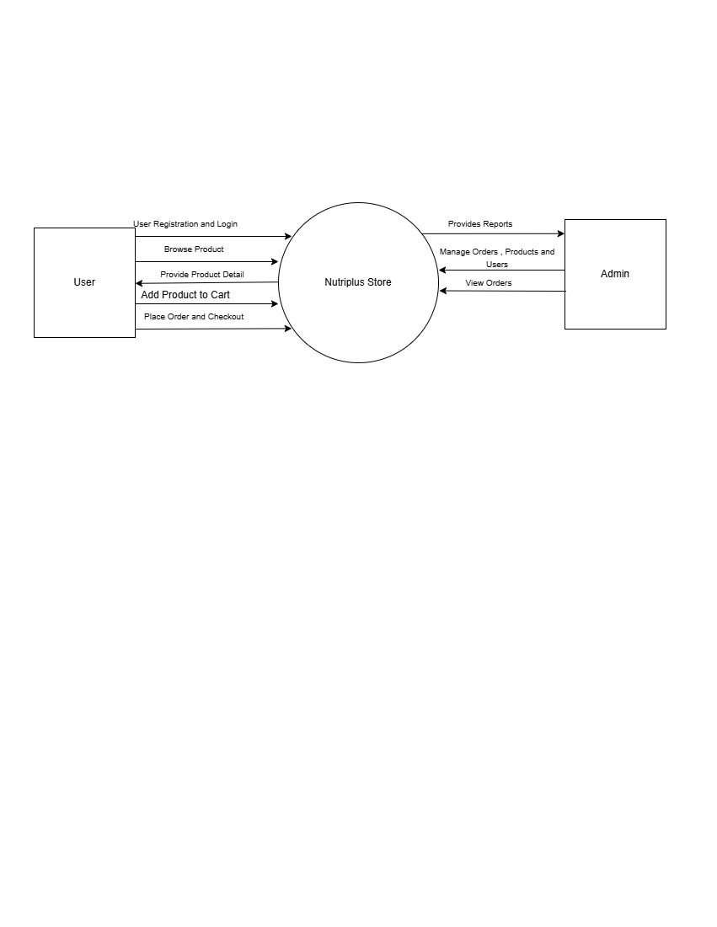
Figure 1: DFD Level 0

The Entity-Relationship (ER) Diagram is a conceptual tool used to visually represent the structure of a database. It helps in the design and modeling of the system by showing the relationships between entities and how data is connected.
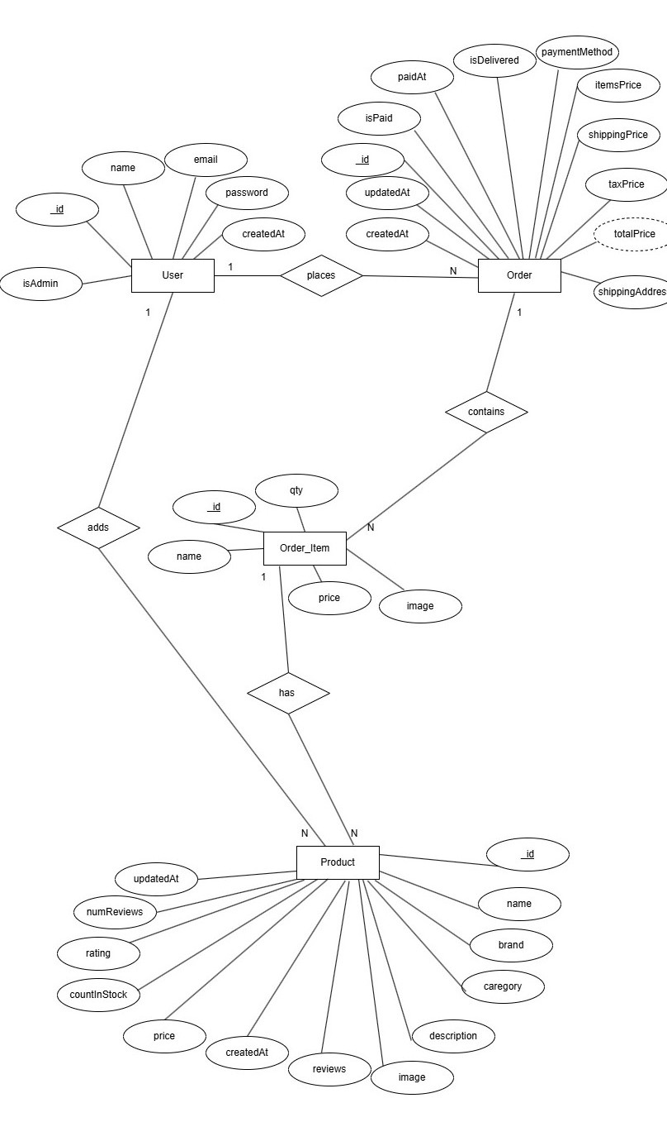
Figure 2: ER Diagram

Process Modelling
Process Modeling is a technique used to visually represent the processes, workflows, or operations that occur within an organization, system, or project. It provides a structured view of how things work, helps identify areas for improvement, and ensures that processes are efficient, consistent, and aligned with organizational goals.

Use Case Diagram

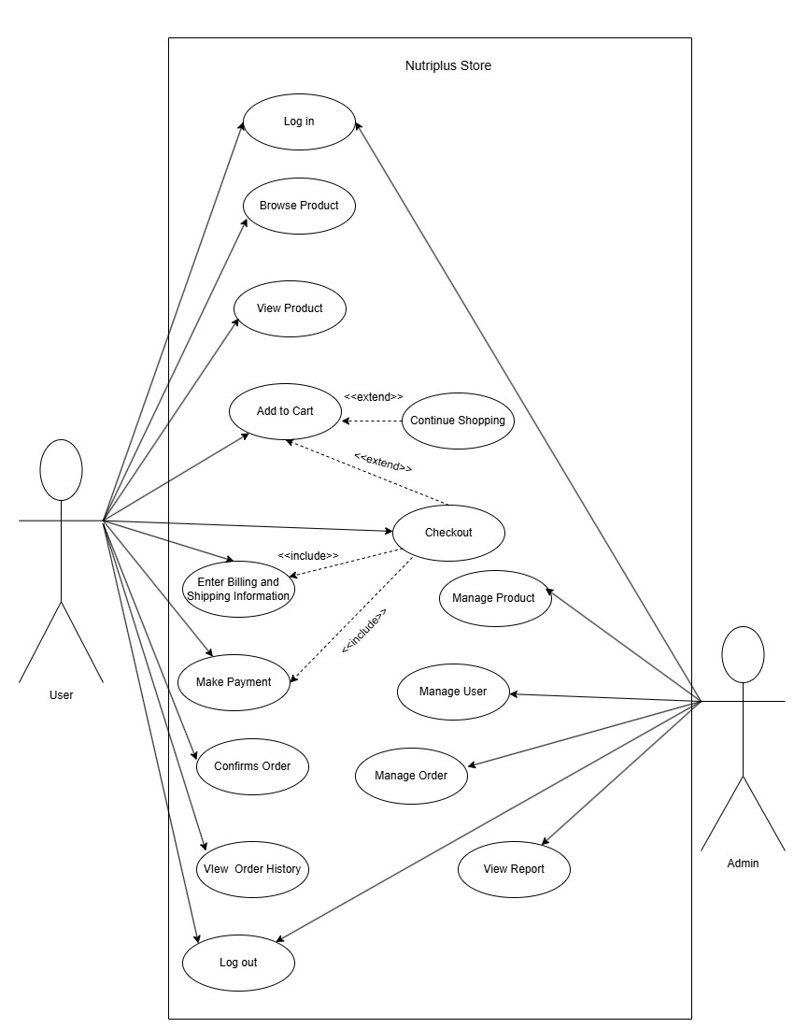
Figure 3: Use Case Diagram

Activity Diagram
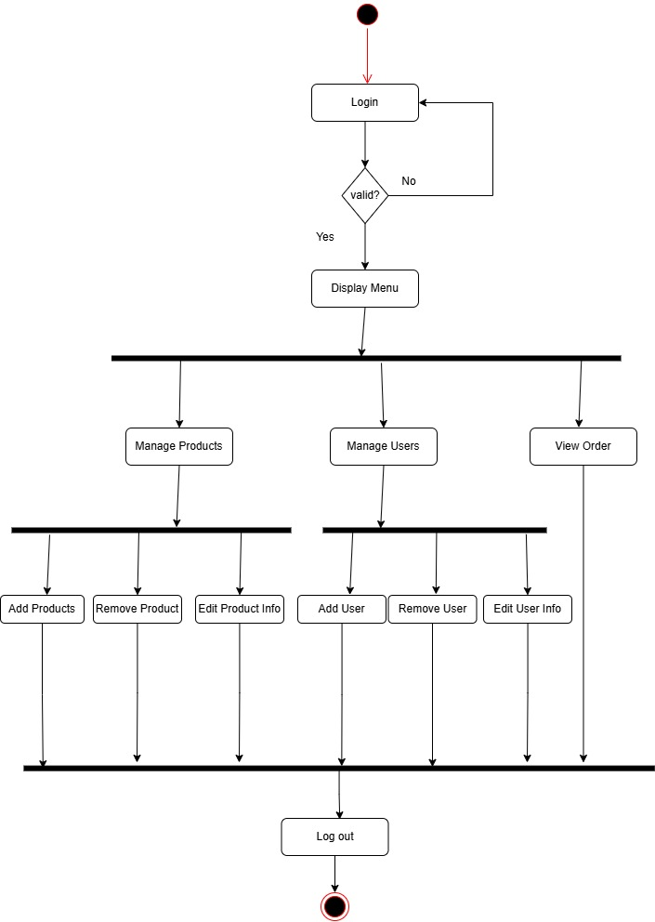
Figure 4: Activity Diagram of Admin

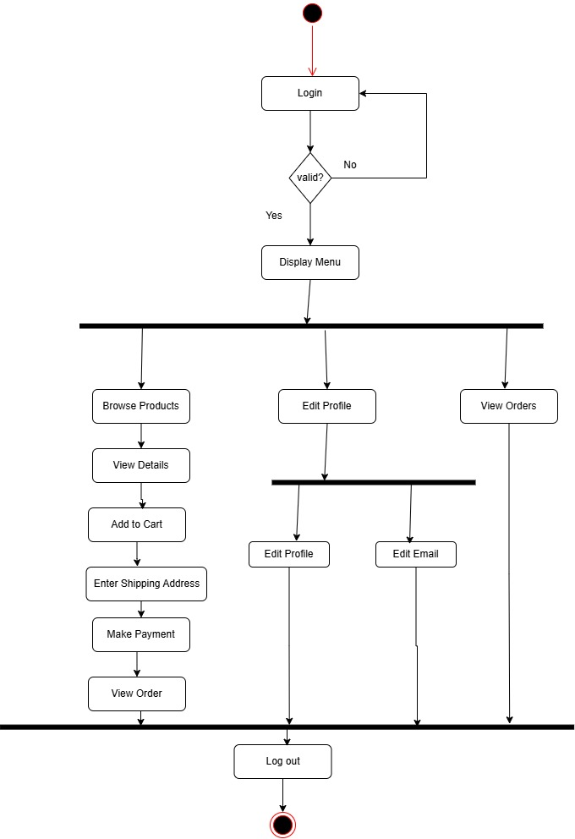
Figure 5: Activity Diagram of User

Sequence Diagram
This diagram represents the interaction between a User, the Web Browser, the Web Server, the Database, and the Payment Gateway during various activities on an e-commerce website.

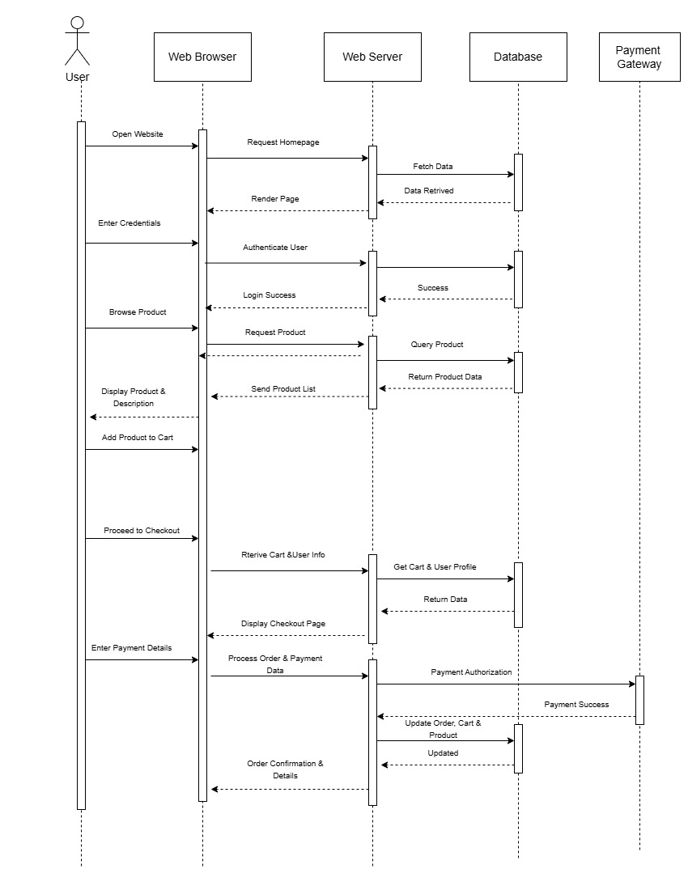
Figure 6: Sequence Diagram

SYSTEM DESIGN

Architectural Design
The system follows a three-tier architecture:
1. Presentation Layer
- Developed using React.js
- UI designed with HTML, CSS, JavaScript, and Bootstrap
- Handles user interaction and input validation
- Communicates with backend via REST APIs
2. Application Layer
- Handles business logic and authentication
- Processes user requests and admin operations
- Manages API routing and server-side validation
3. Data Layer
- Implemented using MongoDB
- Stores users, admin, product, order, and transaction data
- Uses schema models for structured data handling

Database Schema Design
Figure 7:User Schema
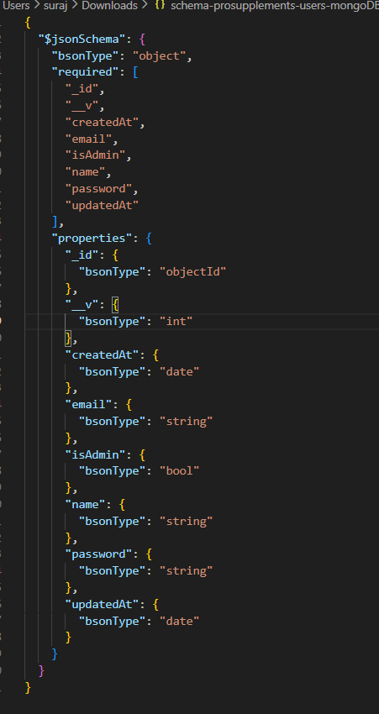
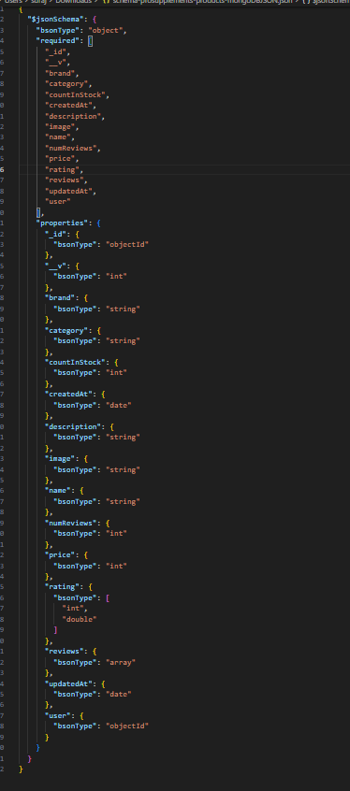
Figure 8: Product Schema

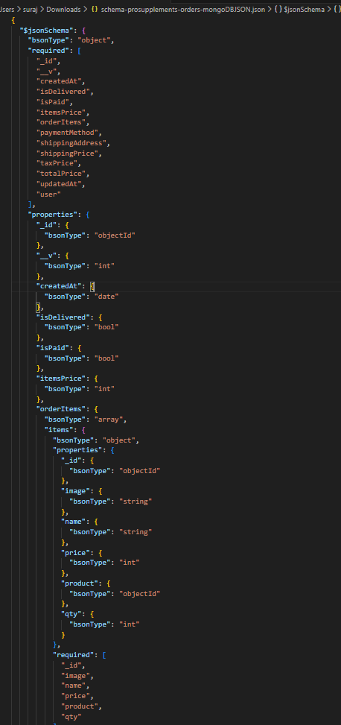
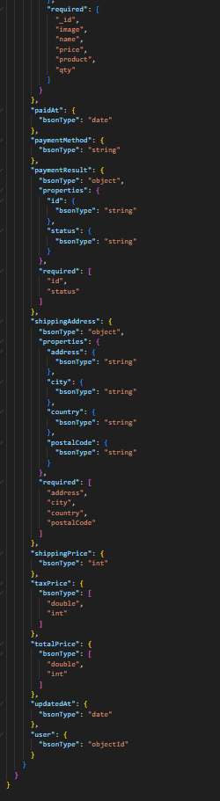
Figure 9: Order Schema

IMPLEMENTATION AND TESTING

IMPLEMENTATION

Tools Used
- Operating System: Windows / Linux / macOS

- Frontend: React.js, HTML, CSS, JavaScript, Bootstrap

- Backend: Node.js, Express.js

- Database: MongoDB

- Development Tools: Visual Studio Code, Postman

- Web Browser: Microsoft Edge

- Design and Wireframing: Draw.io, Figma

Implementation Detail of Module
The implementation of the proposed system for Nutriplus Store, an e-commerce platform for nutritional supplements and health products, was carried out using modern full-stack web technologies. The system was developed using the MERN stack, integrating both frontend and backend modules to ensure a secure, scalable, and user-friendly online shopping experience.

The frontend module of the Nutriplus Store was implemented using React.js, along with HTML, CSS, JavaScript, and Bootstrap, to create a responsive and interactive user interface. React’s component-based architecture enabled modular development and efficient state management, allowing smooth navigation between pages such as product listings, product details, shopping cart, and user authentication pages. Bootstrap was used to enhance responsiveness and ensure compatibility across different devices and screen sizes.

The backend module was developed using Node.js and Express.js, which handle server-side operations, business logic, and API request processing. RESTful APIs were implemented to manage core functionalities such as user registration and login, product management, cart operations, and order processing. Secure authentication and authorization mechanisms were implemented using JSON Web Tokens (JWT) to protect user data and restrict access based on user roles.

The database module was implemented using MongoDB, which stores information related to users, products, orders, and transactions. MongoDB was selected due to its flexibility, scalability, and suitability for handling dynamic data structures commonly found in e-commerce applications. Mongoose was used to define schemas and manage database interactions effectively.

The entire system was developed using Visual Studio Code as the primary code editor. Tools such as Postman were used to test API endpoints and verify backend functionality during development. The implementation focused on providing a smooth browsing experience, secure data handling, reliable order processing, and efficient performance tailored to the needs of health-conscious customers purchasing nutritional supplements online.

TESTING
System testing is a level of software testing that validates the complete and fully integrated software system. The main objective of system testing is to evaluate the end-to-end functionality of the application and ensure that all components work together as expected. Since Nutriplus Store is a web-based e-commerce platform, system testing plays an important role in verifying functional accuracy, usability, and reliability.

In this project, system testing was performed after integrating all frontend and backend modules developed using the MERN stack. The testing focused on essential e-commerce functionalities such as product searching, category filtering, user interaction, and product information display.

Sample Test Case Table
Test Case ID | Module | Test Description | Input | Expected Output | Status
TC01 | Login | Valid Login | Correct Credentials | Login Successful | Pass
TC02 | Login | Invalid Login | Wrong Password | Error Message | Pass
TC03 | Order | Place Order | Valid Order Data | Order Placed | Pass
TC04 | Admin | Add Product | Product Details | Product Added | Pass

CONCLUSION AND FUTURE RECOMMENDATION

LESSON LEARNT
From the development of the Nutriplus Store project, significant knowledge and practical experience were gained in the areas of project planning, system analysis, design, implementation, and testing of an e-commerce application. The project helped in understanding how content and product management systems operate and how they are applied in the e-commerce industry, particularly in the domain of nutritional and health products.

The development process also enhanced skills in designing essential system diagrams such as Data Flow Diagrams (DFD), Entity Relationship (ER) diagrams, use case diagrams, activity diagrams, and flowcharts, which are important for documenting and analyzing system requirements. Additionally, the project improved problem-solving abilities, teamwork, and technical proficiency, which will be beneficial for undertaking similar projects in the future.

CONCLUSION
Nutriplus Store is a web-based e-commerce platform designed to provide a convenient and efficient solution for purchasing nutritional supplements and health-related products online. The system was developed using modern web technologies including the MERN stack, along with HTML, CSS, JavaScript, and Bootstrap, ensuring a responsive, secure, and user-friendly shopping experience.

The main objective of the project was to simplify the buying process for fitness enthusiasts, health-conscious individuals, and professionals by making quality nutrition products easily accessible. The system incorporates essential e-commerce functionalities such as product listing, product search and filtering, shopping cart management, order processing, and secure backend handling. Well-structured system diagrams such as use case, ER, and data flow diagrams clearly represent the system architecture and workflow, making the application easy to understand and maintain.

Overall, the Nutriplus Store project successfully meets its objectives and demonstrates how a customized e-commerce solution can effectively serve a specific market segment while supporting scalability and future enhancement.

FUTURE RECOMMENDATION
Although the Nutriplus Store system fulfills the current project requirements, several improvements and enhancements can be made in the future to increase its effectiveness and reach:
- Improve the user interface design, system performance, and documentation to enhance usability and maintainability.
- Optimize the website to function efficiently in low internet bandwidth environments, allowing broader accessibility.
- Extend the web application into a mobile application for Android and iOS platforms.
- Integrate email and SMS notification services to inform users about order confirmations, delivery updates, and promotional offers.
- Continuously evolve the system by collecting user feedback and implementing improvements through future versions.
- Introduce advanced features such as online payment gateways, product reviews, and analytics dashboards for better customer engagement and business insights.

References
[1] Team H. K., “HealthKart Online Supplement Store,” HealthKart, 2024. [Online]. Available: HealthKart official website. Accessed: 2024.

[2] Team M. B., “MuscleBlaze Official Online Store,” MuscleBlaze, 2024. [Online]. Available: MuscleBlaze official website. Accessed: 2024.

[3] Team G. N. C., “GNC Online Nutrition Store,” General Nutrition Centers, 2024. [Online]. Available: GNC official website. Accessed: 2024.

[4] Team A., “Amazon Health and Supplements Section,” Amazon, 2024. [Online]. Available: Amazon official website. Accessed: 2024.

[5] Team U. X., “Designing an E-commerce Website for Health and Supplement Stores: A UX Case Study,” UX Design Case Studies, 2024. [Online]. Available: UX design resources. Accessed: 2024.

[6] G. Smith, E-Commerce Trends in Health and Nutrition Retail, New York: HealthTech Publishers, 2020.

[7] L. Lee, “Online Supplement Stores: Consumer Behavior and Market Trends,” Journal of Nutrition Business, vol. 12, no. 3, pp. 45–53, 2019.

[8] R. Patel, Digital Transformation of Supplement Brands in E-Commerce, London: Springer, 2021.

[9] S. Chakraborty, “Integrating Fitness and Nutrition Products into Online Platforms,” International Journal of E-Business Research, vol. 16, no. 2, pp. 22–31, 2020.

[10] A. Kumar, Full-Stack Web Development with MERN, New Delhi: TechPress, 2022.

[11] R. Sharma, “Building Scalable E-Commerce Platforms Using MERN Stack,” International Journal of Computer Applications, vol. 175, no. 11, pp. 15–22, 2021.

[12] Y. He, “Enhancing User Experience in E-Commerce Platforms,” Journal of Web Development and Design, vol. 8, no. 4, pp. 101–109, 2019.

Appendices
Snapshots of Wireframes:
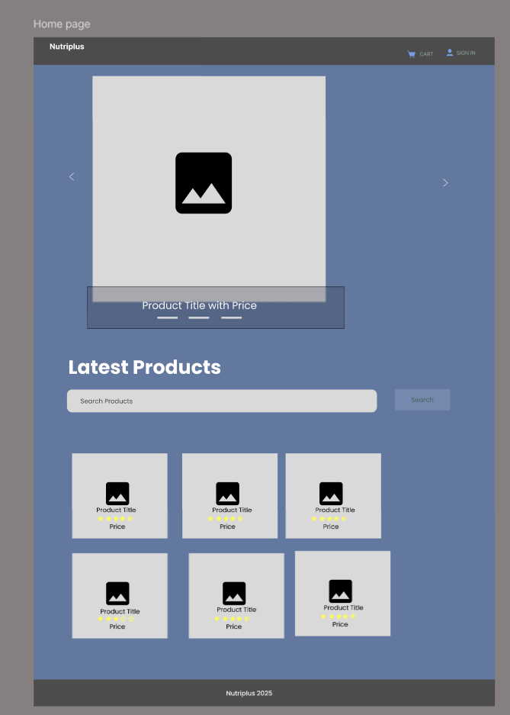
Figure 10: Homepage Wireframe
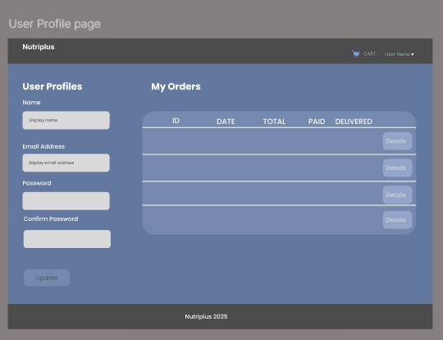
Figure 11:User profile page wireframe
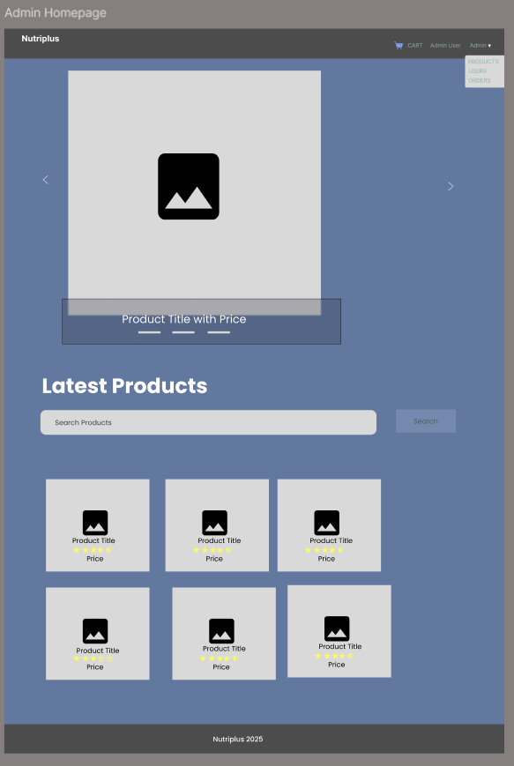
Figure 12: Admin Homepage wireframe
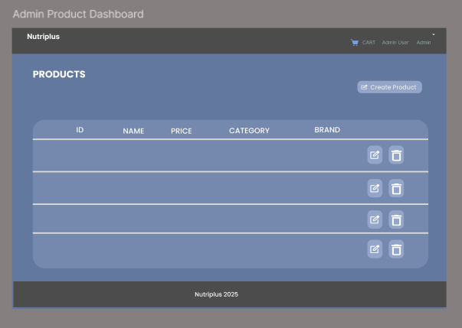
Figure 13: Product Dashboard wireframe
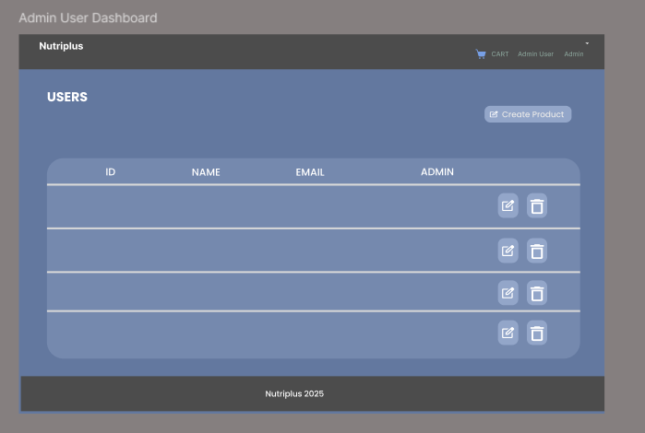
Figure 14: User Dashboard wireframe
Snapshots of Output:
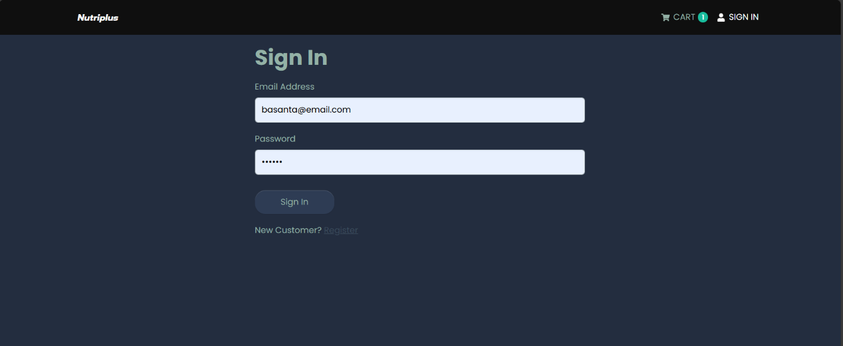
Figure 15: Sign in Page of Nutriplus store
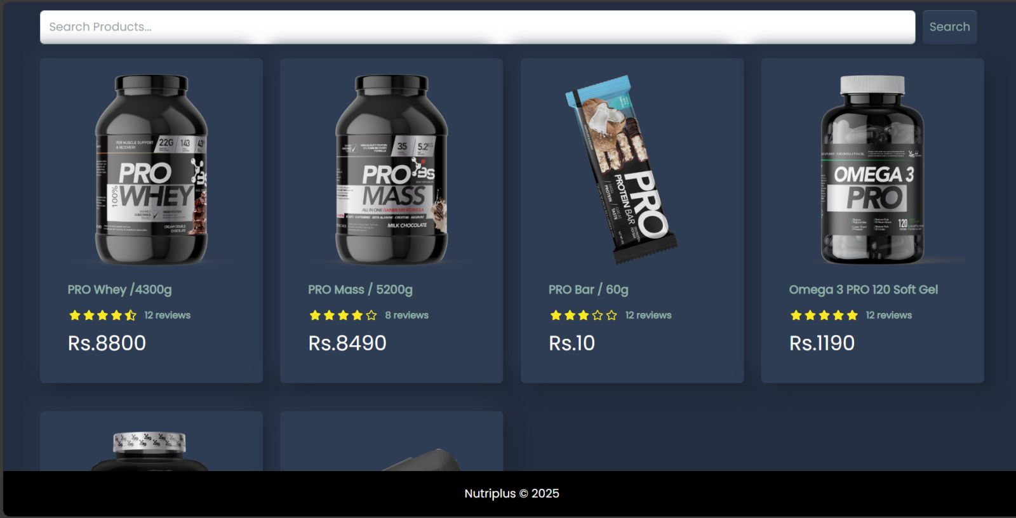
Figure 16: Home Page of Nutriplus store
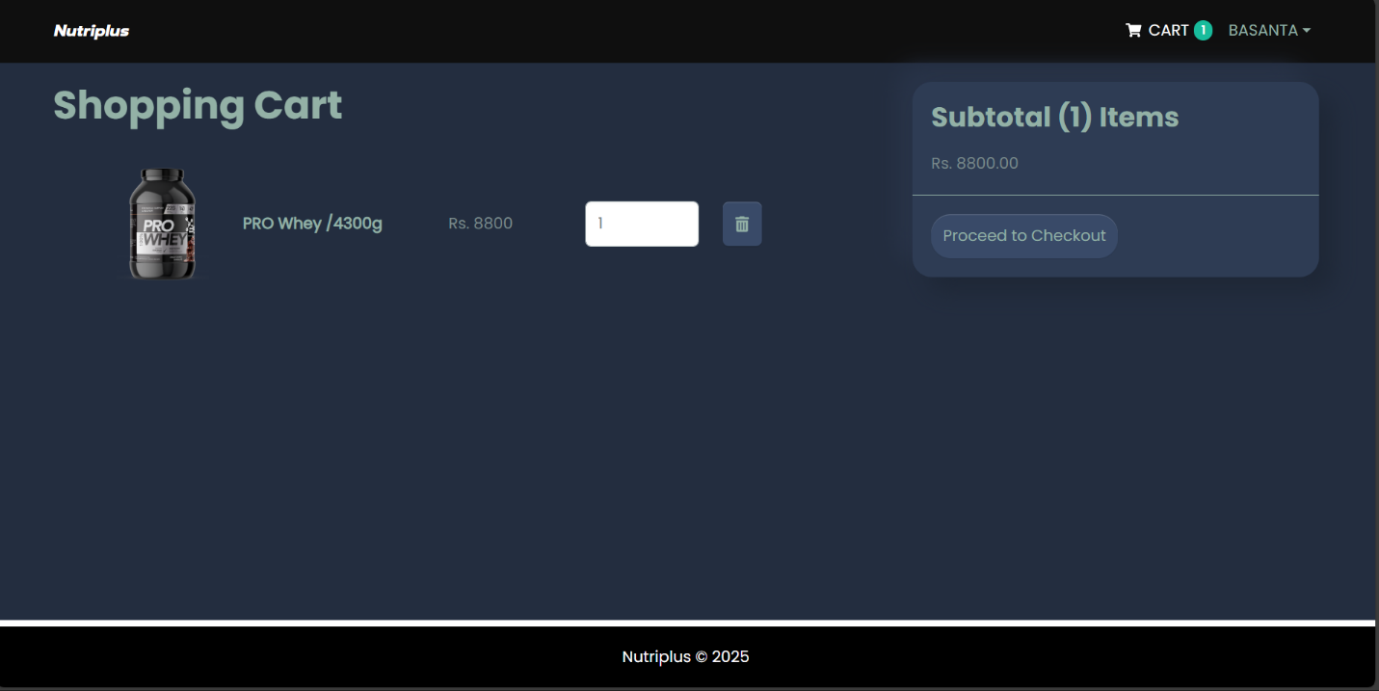
Figure 17: Cart of Nutriplus store
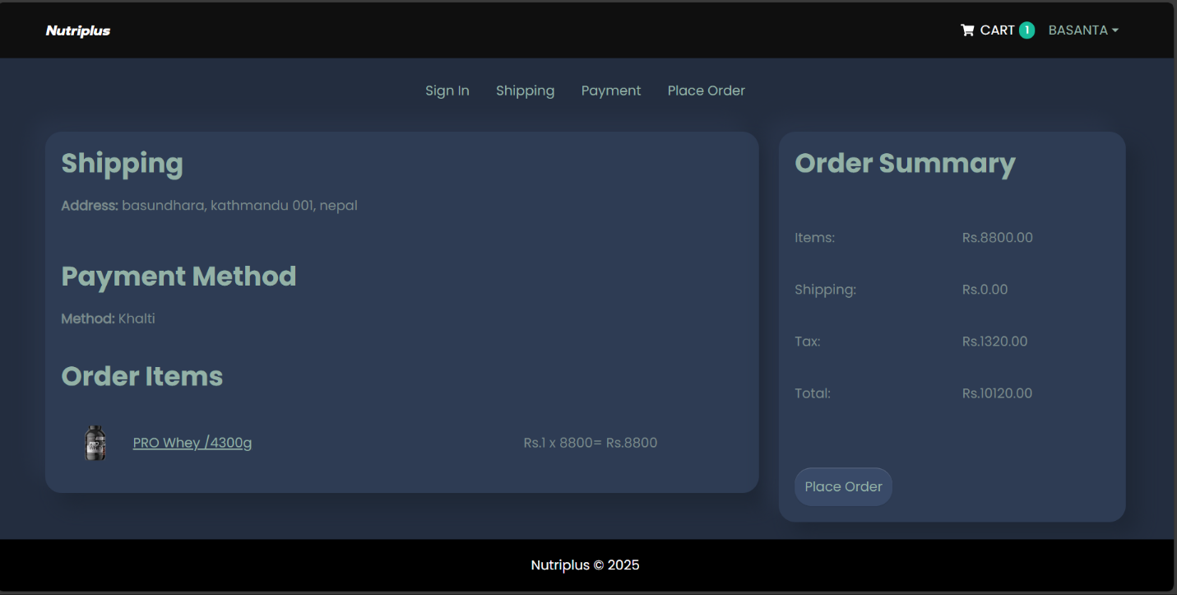
Figure 18: Order Confirmation Page
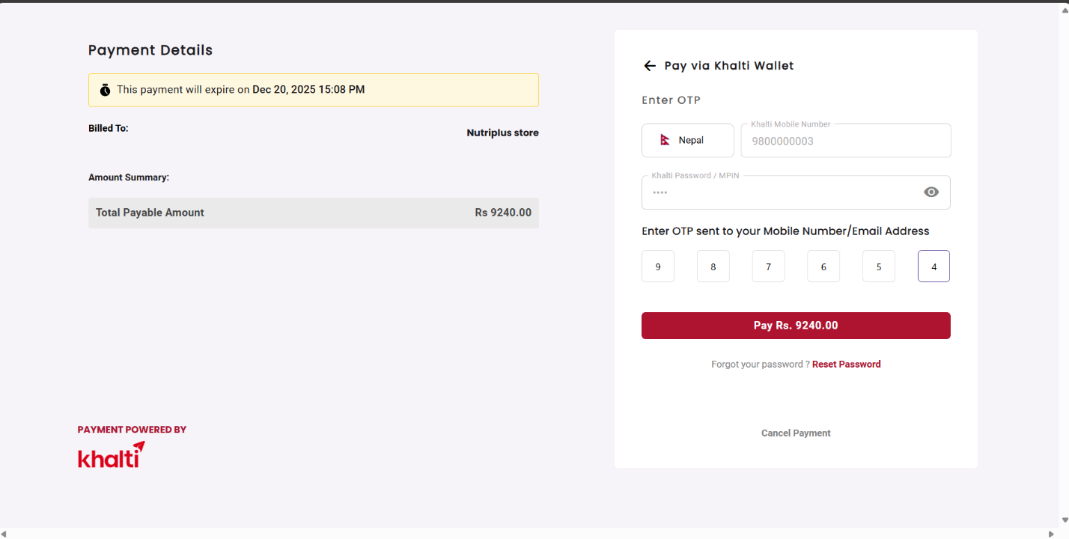
Figure 19: Payment of Nutriplus Store
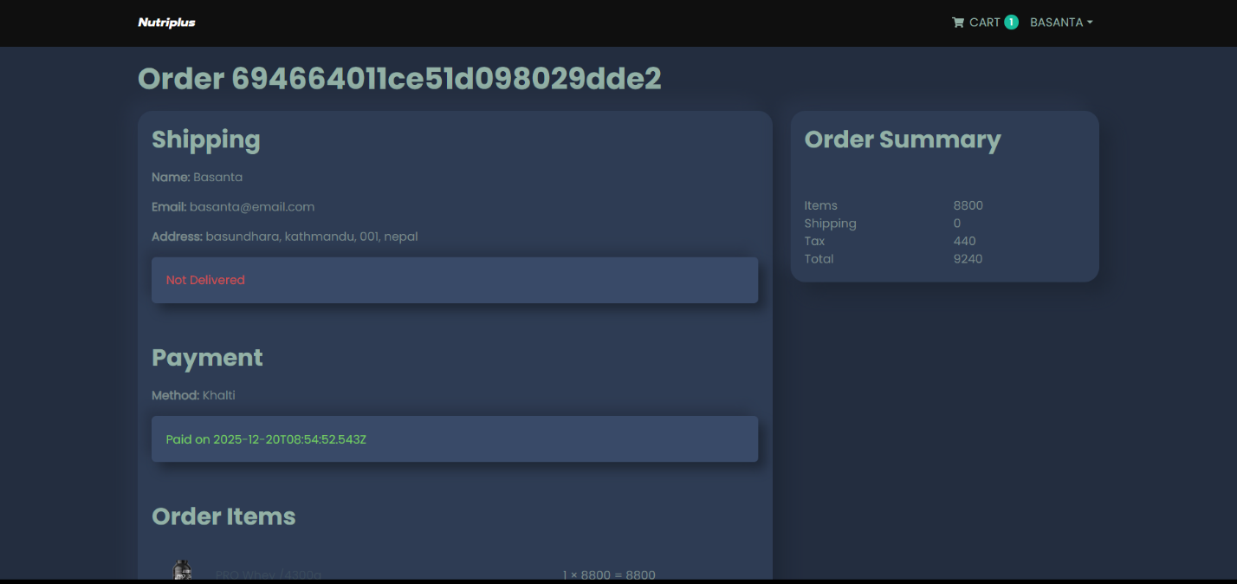
Figure 20:Order Summary Page

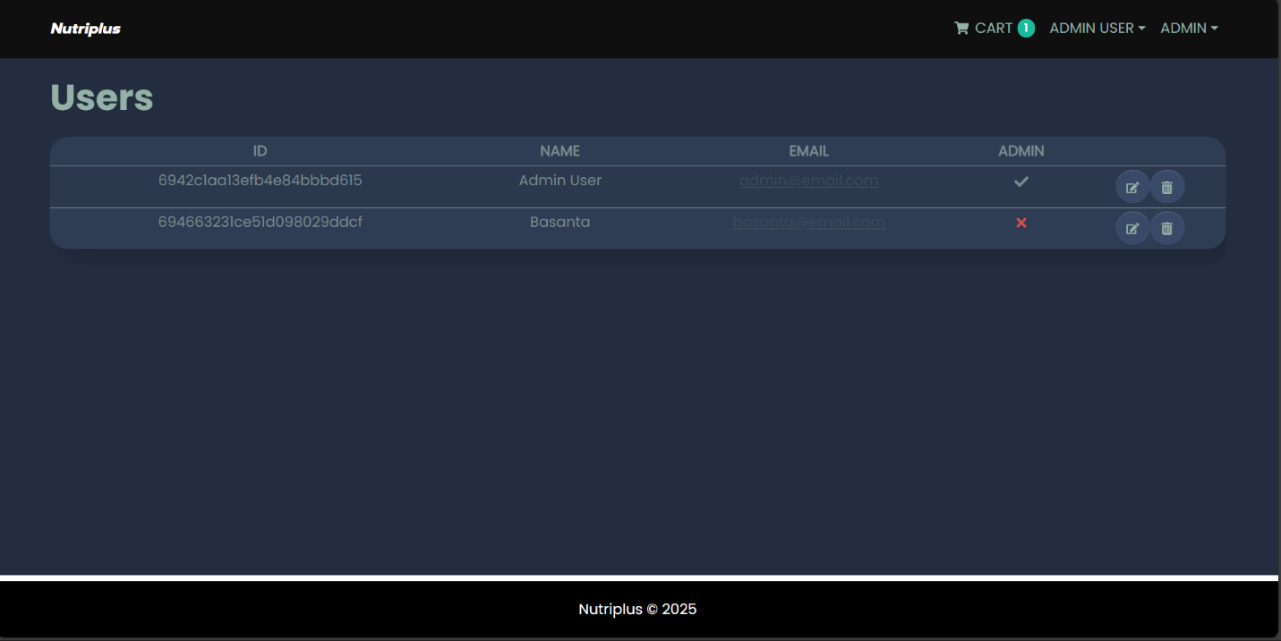
Figure 21: Admin User Dashboard
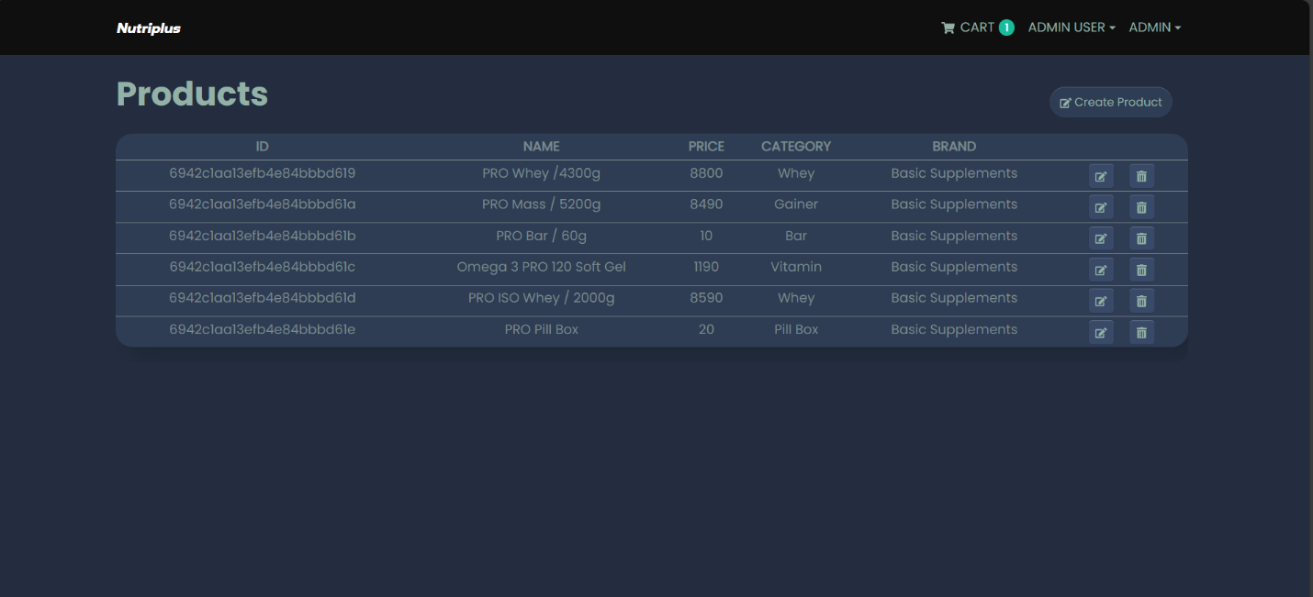
Figure 22: Admin Product Dashboard
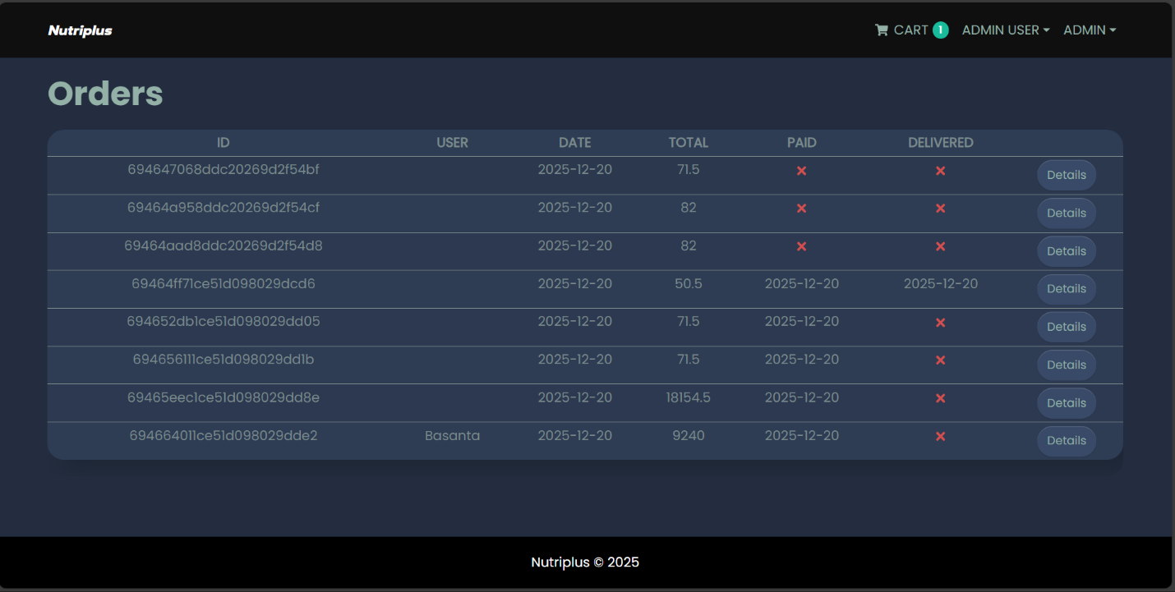
Figure 23: Admin Order Dashboard

